API Client Framework – Design Doc
Author: Nilesh Mevada · Last updated Oct 10, 2026
Status: Draft (v0.3)

Summary
I'm building a small Python library for pulling data out of HTTP APIs reliably. It takes care of the boring-but-hard parts (retries, pagination, provider rate limits, auth, proxies) so that an ingestion job is mostly config plus a few lines of code.
The interesting part, and the reason this isn't just another HTTP wrapper, is quota handling: hourly and daily limits that survive restarts, can be shared between workers, and eventually support large parallel backfills. Loading data into a warehouse or lake is out of scope; for that I plan to hand off to dlt.

Background
Jobs that pull from SaaS and public APIs tend to break in the same few ways. A provider returns 429s or 503s and the job dies instead of backing off. A daily quota runs out halfway through a backfill and nobody notices until the next morning. A crash at page 4,000 means starting again from page 1. Each team ends up writing its own retry loop and its own pagination code, slightly differently each time.
There are good tools nearby (httpx for HTTP, dlt and Airbyte for loading), but none of them treat provider quotas as a first-class problem. I want a single, well-tested layer for that, which I can reuse across projects and later grow into an end-to-end pipeline.

Goals and non-goals
For v1 the library should:
- Support GET, POST, PUT, PATCH, DELETE and HEAD through one code path.
- Handle the common pagination styles out of the box.
- Retry automatically, but only where a retry can actually succeed.
- Respect per-second limits and hourly/daily quotas.
- Be configurable (APIs, auth, forward proxy) from YAML or plain Python.
- Stay small. Two required dependencies, httpx and pydantic; everything else optional.
Things I'm deliberately not doing yet: parallel sharding (designed for, not built), gRPC and WebSockets, storing response data, and anything that needs a cloud account.

Proposed design
The core is a client that pushes every request through a short chain of middleware before it reaches httpx. Each concern lives in its own small class, so it can be tested alone, swapped out, or reordered without touching the rest.
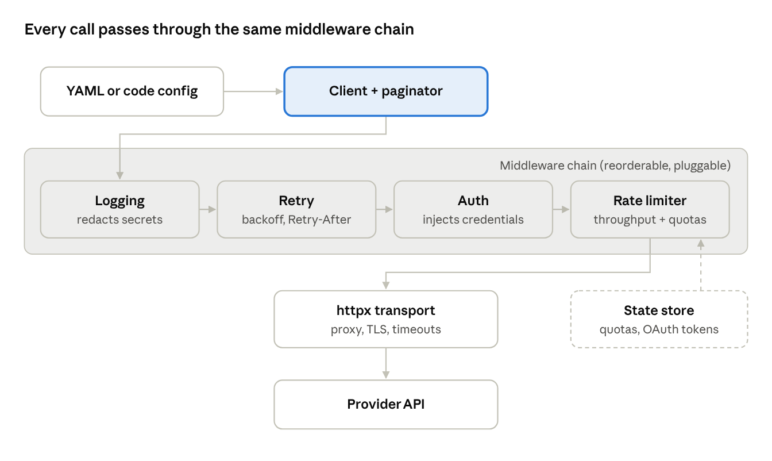
request pipeline · 4 middleware steps

Request path
The order of the chain matters more than it looks. Retry sits outside auth and the rate limiter, so a retried request picks up a fresh token and gets counted against the quota like any other call. With the order flipped, retries would quietly bypass the limiter.
Internally everything is async, with a thin sync wrapper on top. Async isn't strictly needed for v1, but sharding later depends on it, and bolting async onto a sync codebase afterwards is painful.
Retries. Only for responses where trying again can help: 408, 425, 429, 500, 502, 503, 504, plus connection errors and read timeouts. Other 4xx responses fail immediately, since the request itself is wrong. Backoff is exponential with full jitter (so many clients don't all retry at the same instant), and Retry-After wins whenever the server sends it. GET, PUT, DELETE and HEAD retry by default. POST and PATCH only retry if the caller opts in or sets an Idempotency-Key, because a blind retry can create duplicate records.
Pagination. A strategy has two jobs: build the next request from the last response, and pull the items out of a response. I'll ship offset/limit, page number, cursor (located by JSON path), RFC 8288 Link headers and "next URL in the body". Between them they cover the large majority of public APIs. Strategies can change any part of the next request, including the body, which is what GraphQL cursors need. Results come back as lazy iter_pages() / iter_items() generators with optional resume checkpoints.
Rate limits and quotas. These turned out to be two different problems:
- Throughput limits (10 requests a second) are smoothed with a token bucket.
- Quota windows (5,000 an hour, 100,000 a day) are counters that need to survive restarts and sometimes be shared between processes.
When the provider sends X-RateLimit-* or RateLimit-* headers, those correct the local counters, since the server is the source of truth. Some APIs charge per query cost rather than per call, so a request can consume more than one unit. When a quota runs out, the policy either sleeps until the window resets (fine for a few seconds) or raises QuotaExhausted with the reset time (better when the wait is hours).

Auth, proxies and config
Auth types: none, API key (header or query string), bearer, basic, OAuth2 client credentials, and a custom hook that takes any callable (handy for HMAC request signing). The OAuth2 one caches its token, refreshes shortly before expiry, and retries once on a 401. If several requests notice an expired token at the same moment, only one of them refreshes it.
A forward proxy can be set per API or per endpoint, including SOCKS and a no_proxy list. There's also a switch for whether to honour HTTP(S)_PROXY from the environment. Corporate proxies often re-sign TLS, so custom CA bundles and client certificates are supported from day one rather than as an afterthought.
Config can be YAML or Python; both end up as the same Pydantic models. Secrets never go in the file itself, only references like ${GITHUB_TOKEN}, and the loader complains if something looks like a pasted key. A typical API entry:
defaults:
timeout: {connect: 5, read: 30}
retry: {max_attempts: 4, backoff_base: 0.5, max_backoff: 30}
proxy: {url: "${HTTPS_PROXY}", no_proxy: ["localhost"]}
apis:
github:
base_url: https://api.github.com
auth: {type: bearer, token: "${GITHUB_TOKEN}"}
rate_limits:
- {window: hour, limit: 5000, on_exhausted: raise}
endpoints:
list_repos:
method: GET
path: /users/{user}/repos
pagination: {type: link_header, per_page: 100}
Nothing here assumes REST. Request and response bodies go through pluggable codecs (JSON, form, XML, raw), and a small response classifier decides whether a response is OK, retryable or a failure. That matters for GraphQL and JSON-RPC, which happily return HTTP 200 with an error in the body.

State, logging and errors
Only a few things need to outlive the process: quota counters (so a restart doesn't reset a daily limit), OAuth tokens, pagination checkpoints, and optionally ETags for conditional requests. They sit behind a tiny StateStore interface with three implementations: in-memory (the default), SQLite (one machine, no extra dependency) and Redis (several workers sharing one quota). I'm intentionally not storing response data.
Logging uses the standard logging module under an apiframework logger, and the library never configures handlers itself, since that's the application's decision. Each record has the method, the URL template rather than the filled-in URL (lower cardinality, no leaked IDs), status, latency, attempt number and remaining quota. Auth headers, cookies and API keys are redacted by default; bodies are only logged at DEBUG and only if you ask. Hooks (on_request, on_retry, on_rate_limited and so on) are there for anyone who wants metrics, and OpenTelemetry is an optional extra.
Errors form a small hierarchy under ApiError: HTTPStatusError (which carries the response), RetryExhausted, QuotaExhausted, AuthError and ConfigError. Timeouts are always on, and there are no module-level globals, so two clients in one process never interfere.
Rough layout:
apiframework/
client.py config.py endpoints.py errors.py cli.py
middleware/ # logging, retry, auth, ratelimit
auth/ # api_key, bearer, basic, oauth2, custom
pagination/ # offset, page, cursor, link_header, next_url
codecs/ # json, form, xml, raw
state/ # memory, sqlite, redis
adapters/dlt.py # optional extra
tests/ examples/ Dockerfile docker-compose.yml

Alternatives considered
requests instead of httpx. requests is more familiar, but it's sync-only and I'd have to build async and HTTP/2 support myself. httpx gives sync and async with one API, plus proxies and fine-grained timeouts.
Using tenacity for retries. It would work, and it's a reasonable fallback. I'd still rather own the roughly 100 lines of retry logic, because retries have to cooperate with the quota limiter, the idempotency rules and the response classifier, and keeping that visible makes it easier to reason about.
Building on an existing data tool. I looked at the three obvious candidates:
Tool | Licence | Good at | Why I'm not building on it
dlt | Apache 2.0 | Loading, schema evolution, incremental state, many destinations | It already ships its own REST client, so a plugin would mostly duplicate it. I'll use dlt for loading via an adapter instead.
Airbyte | Elastic License 2.0 (source-available) | Large connector catalogue, UI, managed cloud | It's a platform to operate, and its connector kit ties the work to Airbyte's protocol.
Singer / Meltano | Open spec / MIT | Reusing community taps | Each tap implements retries and limits its own way; I want one consistent layer.
The split I settled on: build the extraction side (retries, quotas, pagination, checkpoints, later sharding) myself, and hand records to dlt through an optional apiframework[dlt] adapter for everything after that. If a well-maintained connector already exists for a source, that's usually the better choice than this library.

Testing
Most tests are unit tests with HTTP mocked by respx: every retry path, Retry-After parsing in both formats, quota window rollover, each pagination strategy. The clock is injected rather than slept on, so a test of a daily window runs in milliseconds.
Integration tests run against free public APIs, chosen because each one exercises something specific:
- JSONPlaceholder for the full set of HTTP verbs.
- httpbin for forced status codes (503, 429), slow responses, basic and bearer auth, and checking what headers actually went out.
- GitHub's REST API for Link-header pagination and real rate-limit headers. Its low unauthenticated limit makes a good real-world quota test.
- PokéAPI for offset pagination with a next URL in the body.
Public APIs are flaky, so these are tagged integration and run nightly rather than on every push. httpbin, Redis and mitmproxy also run locally through docker-compose, which keeps CI stable and gives me a proxy to test against.

Milestones and cost
v1 is free to build and run. Paid infrastructure only comes in later, and only on purpose.
Stage | What's in it | Cost
1 | The library, tests, public GitHub repo and Actions, docker-compose (httpbin, Redis, mitmproxy, MinIO, DynamoDB Local), local Kubernetes with kind | Free
2 | A small AWS deployment: Lambda on an EventBridge schedule, S3, DynamoDB on-demand, SSM parameters, no VPC or NAT | A few dollars a month at most
3 | Production scale: EKS, ElastiCache, Fargate, a managed orchestrator, NAT Gateway | Real ongoing cost
To keep Stage 1 honest, cloud code only lives in optional extras like [aws], a stage setting points clients at local emulators or real AWS, and tests that cost money have their own marker and never run in default CI. Before Stage 2 I'll set up a budget alert, tag everything, and keep infrastructure in Terraform so it can be torn down in one command.
Rough order of work:
- Config, client, transport (proxy, TLS)
- Auth
- Retries
- Pagination
- Rate limits with the in-memory store
- SQLite and Redis stores
- Hooks, JSON logs, OpenTelemetry extra
- CLI runner, Dockerfile, docker-compose, dlt adapter
- Docs and examples
After that, the plan is a reference pipeline: a public API (probably GitHub events) through this library and dlt into Parquet/Iceberg on MinIO, then S3; dbt for transformations, Dagster or Airflow for scheduling, data quality checks, and a backfill benchmark (records, shards, quota used, failures recovered).
Tooling: uv, ruff, mypy --strict, pre-commit, GitHub Actions on Python 3.10 to 3.13, semantic versioning, Apache 2.0 licence.

Future work
None of this is in v1, but the design leaves room for each piece so it can be added as a new module rather than a rewrite.
Parallel shards. Some APIs let you split one big query into independent ranges (by date, by ID, by region) and pull them in parallel. That isn't pagination: each shard pages through its own results. The plan is a shard planner that turns one query into a list of half-open ranges, and an executor that runs them with a concurrency cap. All shards share one quota, each keeps its own checkpoint so a failed run only retries what's missing, and a shard that hits a provider's result cap gets split in two. To make this cheap later, v1 already treats requests as immutable specs that can be cloned with overrides, keeps pagination state inside the iterator, and looks rate limiters up by key instead of tying them to one client.
sharding:
planner: date_range
param_start: created_after
param_end: created_before
range: {start: "2025-01-01", end: "2026-01-01", step: 7d}
max_parallel: 8
on_failure: collect
Docker and Kubernetes. The CLI runner (apiframework run job.yaml) goes into a slim, non-root image. Config comes from ConfigMaps and Secrets, SIGTERM triggers a checkpoint and a clean exit, and CronJobs handle schedules. Indexed Jobs line up nicely with shards later, and the Redis store lets pods share a quota.
AWS. Lambda plus EventBridge for small, frequent pulls; Fargate or Batch for long backfills. A DynamoDB state store would cover serverless setups, secrets would come from SSM or Secrets Manager through IAM roles, and a SigV4 auth plugin would cover API Gateway.
The full pipeline. dlt handles loading; orchestration (Dagster, Airflow or Step Functions) calls the runner, and checkpoints mean a retried task resumes instead of starting over. Logs go to stdout as JSON for whatever the platform collects.
Smaller ideas for later: a circuit breaker, typed responses via Pydantic models, streaming and Server-Sent Events, and maybe a separate gRPC client that reuses the retry and quota logic.

Open questions
- ☐ Repo name, and public or private? Public keeps GitHub Actions free.
- ☐ Ship the sync wrapper in v1, or async only at first?
- ☐ Will several processes share one quota soon? If so, the Redis store moves up the list.
- ☐ When sharding happens, will shards ever need different hosts or credentials, or only different parameters?
- ☐ Apache 2.0 or MIT? Leaning Apache for the patent grant.

